Project Development Phase
S. No. | Parameter | Values / Project Details | Screenshot / Evidence
1. | System Summary | The Incident Lifecycle Management System is developed on ServiceNow to manage the complete life of an IT incident: logging through the Service Portal, Now Mobile app or email, automatic priority and assignment, SLA tracking and escalation, resolution and closure, notifications, and reporting. Support agents work on incidents and update statuses through ServiceNow. | 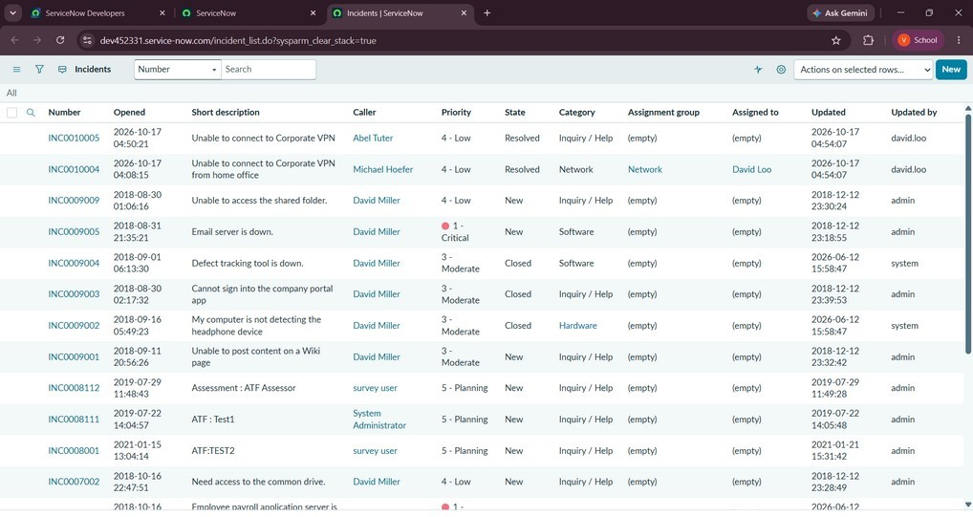
Model Performance Test
Date | 21-10-2026
Team ID
Project Name | Incident Lifecycle Management System in ServiceNow
Maximum Marks | 10 Marks
Model / System Performance Testing
Project team shall document the system summary, functional accuracy, performance observations, and user acceptance results for the incident management system. Enter measured values and insert screenshots from the actual ServiceNow instance before submission.

S. No. | Parameter | Values / Project Details | Screenshot / Evidence
2. | Functional Accuracy | Incident creation and required-field validation – verify with actual test results.  Priority calculation and assignment rules – verify incidents reach the correct group.  SLA tracking and escalation – verify SLA starts, pauses and breach alerts work.  State changes (In Progress, On Hold, Resolved, Closed) and notifications – verify each is reflected and the email is sent.  Access control – verify only authorized roles can view or update incidents. | 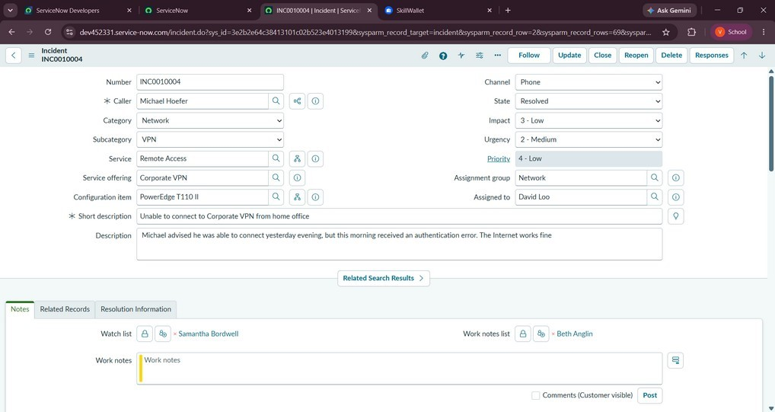
3. | Performance Testing | Service Portal page loading time: record measured average (target: under 5 seconds). Measured: ______  Incident submission response: record measured average (target: under 3 seconds). Measured: ______  Record retrieval time: measure when opening incident, user and SLA records. Measured: ______  Concurrent-user behavior: test with the number of users available in your instance and note any errors or delays.  Observed: ______ | 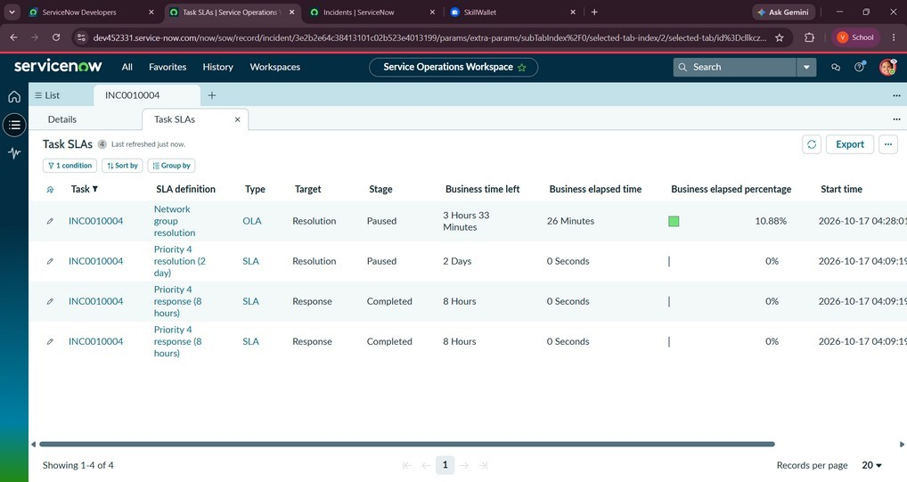
4. | User Acceptance Testing | Validate that a user can log an incident, receive confirmation and track its status.  Validate that an agent can be assigned the incident, put it On Hold, resolve it with notes, and that the user can confirm or reopen it before it closes.  Validate that managers can view dashboards and SLA reports.  Record actual Pass / Fail results. | 